
23CSE203
DATA STRUCTURES AND ALGORITHM

Submitted by
Name | Venkateswari. G
Roll.no | AV.SC.U4CSE25029
Section | CSE-A

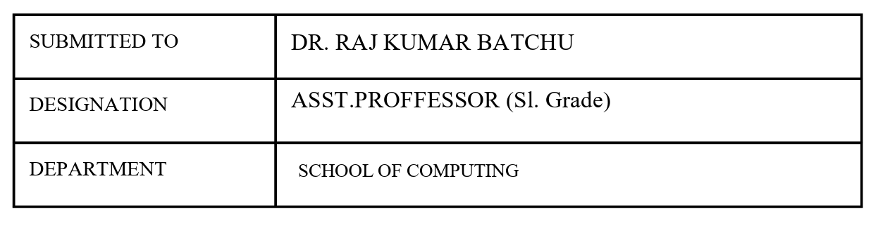
Credit | 5

Index
S.no | Title | Page.no | Remark
1. | A) A rocket launch system displays a countdown before launch. Instead of using loop, implement the countdown using recursion. Write a recursive program to display a countdown from n to 1 followed by launch.  B) Bank calculates the growth of an investment using compound intrest. The formula requires calculating powers, which can be implemented recursively. Write a recursive program to calculate p^{n}(power), where P=principal growth factor, n=no.of years.  C) Write a recursive progrsm to print the first n terms of fibanocci series  D) An hr department stores employee ids in a list develop a recursive program to search for a given employee id. Write a recursive function to search for an employee id in the list.  E) In a logistics the no.of possible ways to arrange n different parcels calculate using the factorial (n!). develop a recursive program to calculate the factorial of given number. | 4-13
2. | A) write a python program to perform linear search on the given input  B) Write a python program to perform binary search on the given input. Verify by taking sorted array and unsorted array as a list. | 14-18

Week-1
A) Aim: A rocket launch system displays a countdown before launch. Instead of using loop, implement the countdown using recursion. Write a recursive program to display a countdown from n to 1 followed by launch.
Program:
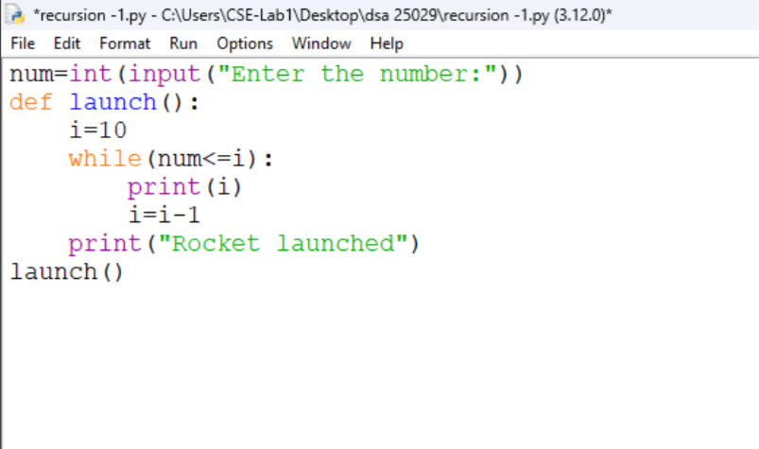
Output:
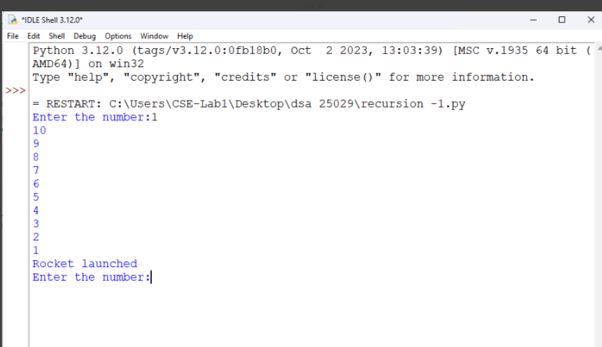
Explanation:
- It takes a number as input from the user and stores it in num.
- It creates a function named launch().
- It starts the countdown from 10 by assigning i = 10.
- It prints the value of i as long as num <= i.
- It decreases the value of i by 1 after each iteration.
- When the loop ends, it prints "Rocket launched" and executes the function using launch().
Error table:
s.no | Error obtained | Rectification
1. | Infinite loop | Iteration at correct place
2. | Calling function at wrong place | Placed with correct syntax

B) Aim: Bank calculates the growth of an investment using compound intrest. The formula requires calculating powers, which can be implemented recursively. Write a recursive program to calculate p^{n}(power), where P=principal growth factor, n=no.of years.
Program:
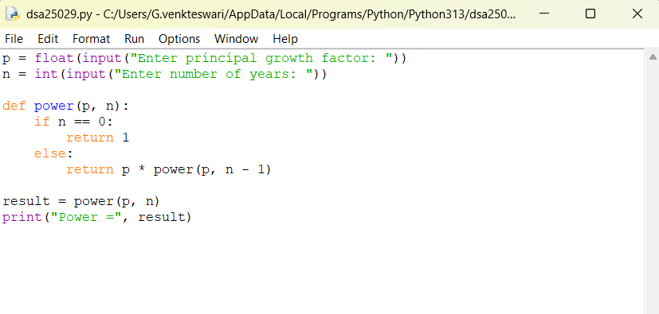
Output:
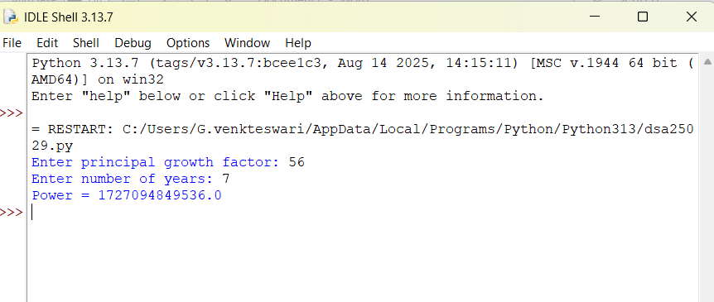

Explanation:
- The program takes the principal growth factor p and number of years n as input.
- It defines a recursive function power(p, n).
- If n is 0, the function returns 1 (base case).
- Otherwise, it returns p * power(p, n-1).
- The recursive calls continue until n becomes 0.
- The final value of pⁿ is displayed as the output.
- Error table:
s.no | Error obtained | Rectification
1. | Return 0 | Return 1
2. | print | return

C) Aim: Write a recursive progrsm to print the first n terms of fibanocci series
Program:
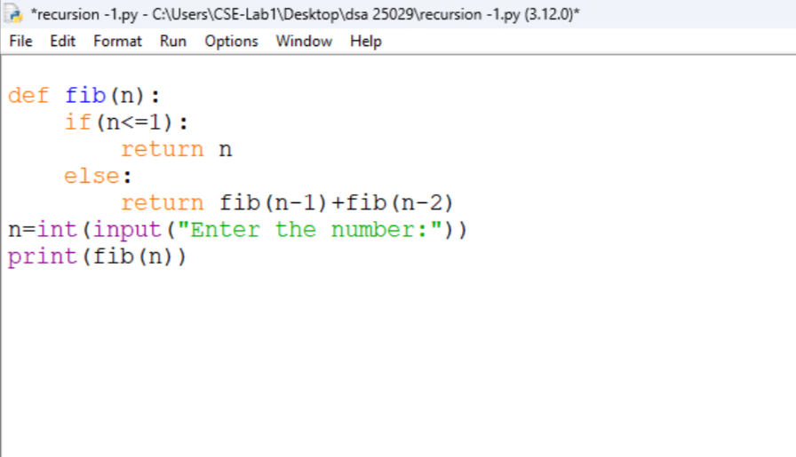
Output:
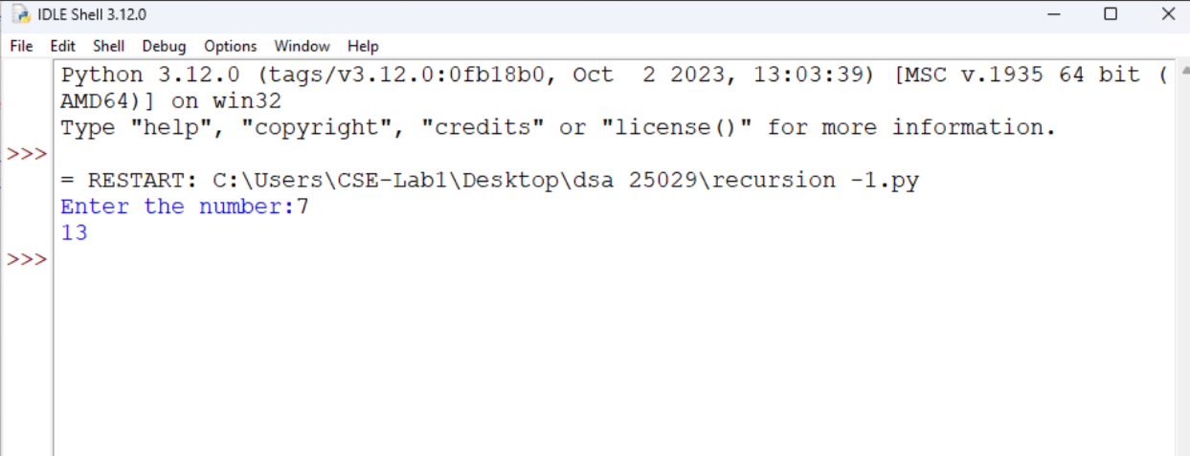

Explanation:
- For entering the number as input from user we defined as n
- We declared variable for formula.
- If input number is less than one then it return “1”
- Or it will goes under fibanocci iteration.
Error:
s.no | Error obtained | Rectification
1. | Forgot to declare n<=1 | rectified
2. | Formula mistake | rectified

D) Aim: An hr department stores employee ids in a list develop a recursive program to search for a given employee id. Write a recursive function to search for an employee id in the list.
Program:
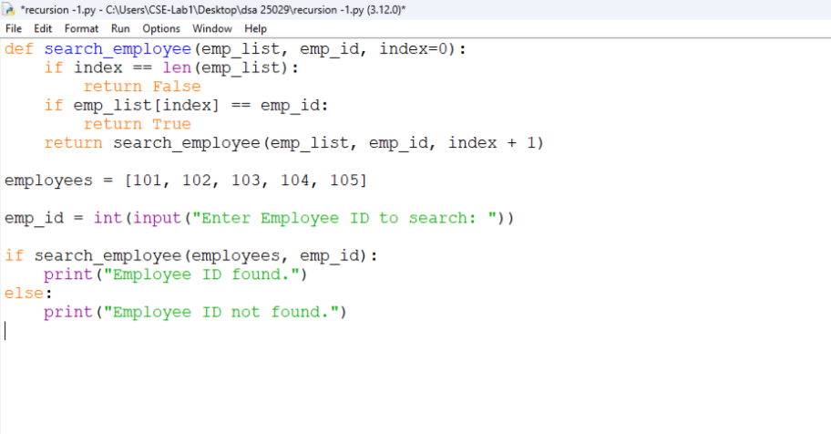
Output:
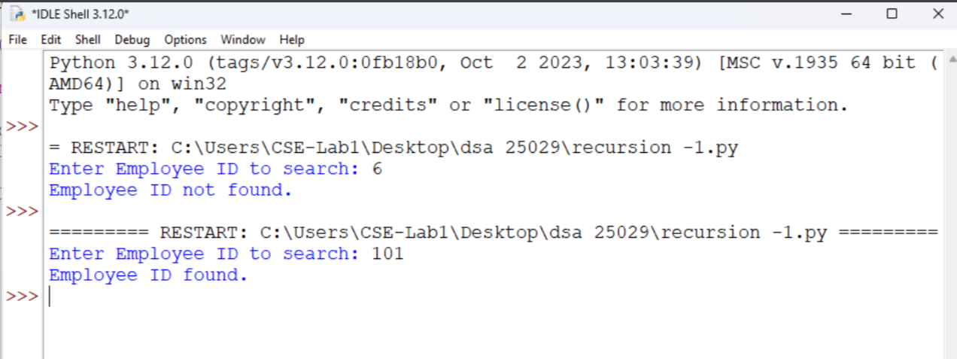

Explanation:
- The program creates a function to search for an employee ID in a list.
- It checks one employee ID at a time, starting from the first ID.
- If the entered employee ID matches the current ID, it returns True.
- If it does not match, the function moves to the next ID using recursion.
- If all employee IDs are checked and no match is found, it returns False.
- Finally, the program displays "Employee ID found." if the ID exists; otherwise, it displays "Employee ID not found."
- Error:
s.no | Error obtained | Rectification
1. | Emp lst | Emp_list
2. | print | Return

E) Aim: In a logistics the no.of possible ways to arrange n different parcels calculate using the factorial (n!). develop a recursive program to calculate the factorial of given number.
Program:
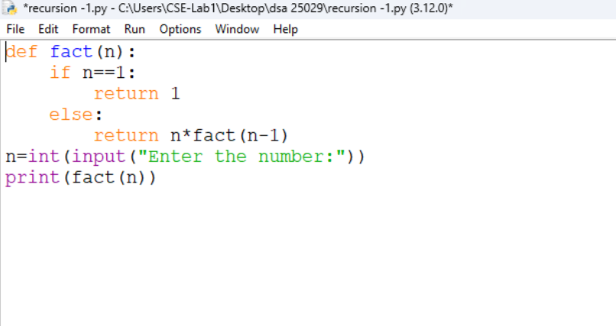
Output:
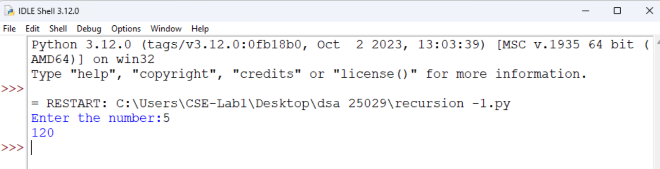

Explanation:
- The program defines a recursive function fact() to calculate the factorial of a number.
- It takes a number as input from the user.
- If the number is 1, the function returns 1 (base case).
- Otherwise, it multiplies the number by the factorial of the previous number (n-1).
- The recursive calls continue until the number becomes 1.
- Finally, the program prints the factorial of the given number.
Error table:
s.no | Error obtained | Rectification
1. | n+1 | n-1
2. | Syntax error | Rectified

WEEK-2
- AIM: Write a python programm to perfor linear search on the given input.
Program:
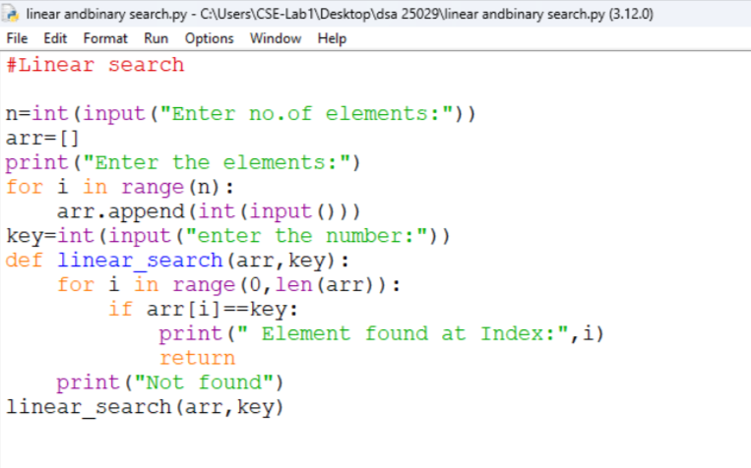
Output:
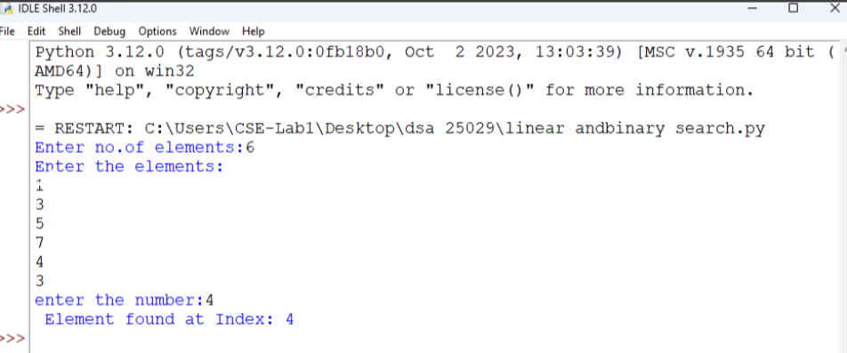

Explanation:
- In linear search we can append elements in sorted or unsorted way also.
- After placing the target we need to check the all the elements in a order.
- The time complixity is O(n).
- The target element may be found at beginning or last or at middle.
Error table:
s.no | Error obtained | Rectification
1. | Return placed in wrong place | Corrected later
2. | Calling the function | Rectified

B) Aim: Write a python program to perform binary search on the list.
Program: Unsorted
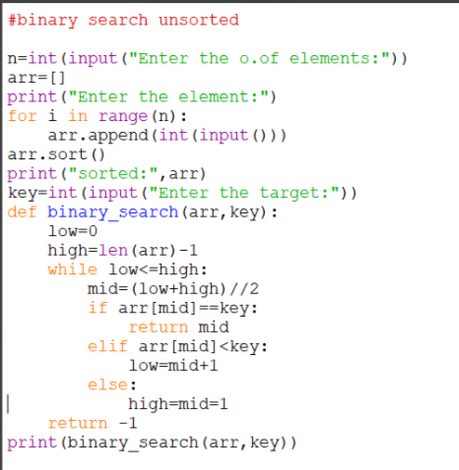
Output:
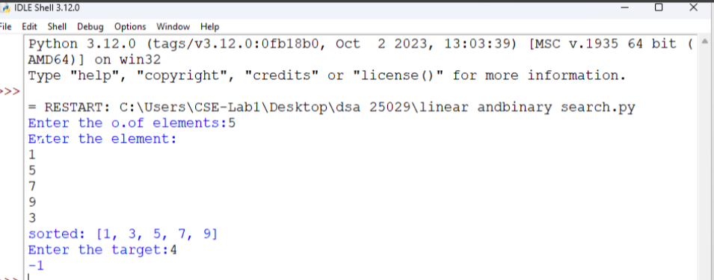

Program: Sorted
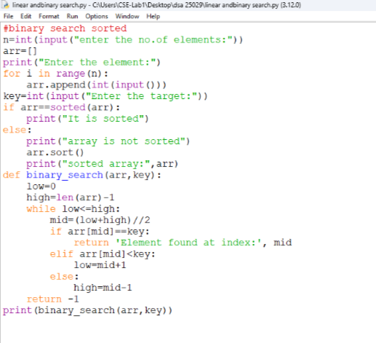
Output:
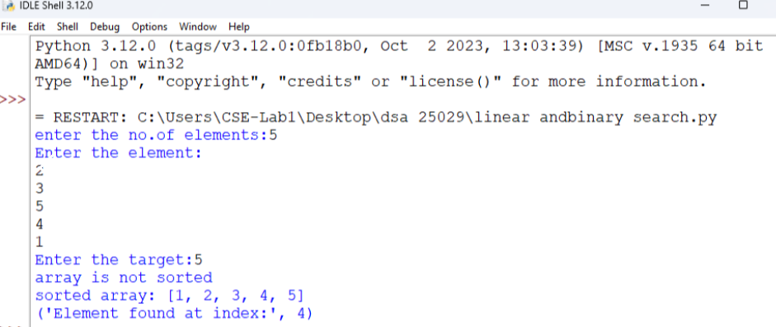

Explanation:
- The binary search should always executed in sorted order.
- Either it can be ascending or descending order.
- So the program is in unsorted order so we need to do sorting first later the binary search is executed.
- Error table:
s.no | Error obtained | Rectification
1. | Mistakes in main logic | Rectified
2. | Errors in conditions | Rectified

